ICT 401 GROUP 7

CONTRIBUTORS

1. LUCAS-ADEBAYO DANIEL IYANUOLUWA
2. CHUKWUEMEKA-EZEH ESTHER CHINENYE
3. AYEROMARA ISAIAH JESUPEMI
4. ADEEKO DANIEL ADEWUNMI
5. ESHO PRECIOUS OLUWASOROMIDAYO
6. AKINYEMI OMOLOLA FAITH
7. YABA-SHIAKA SHEMAIAH WAMBEBE
8. ELEBESUNU ELIJAH OSEJEME
9. IMOLORE PRECIOUS OZWEM
10. AFOLABI VICTORY

26th November, 2024.

1. Problem statement

Sleep quality is a crucial factor in determining students’ overall health and academic performance. To categorize sleep quality into actionable groups (good vs. poor). We want to identify the most influential lifestyle habits that impact sleep quality and also provide insights that can help students adopt healthier routines for better sleep and improved academic performance.

1. The dataset: The chosen dataset has a target variable of “Sleep_Quality” which would be reduced to zeros and ones to manipulate it with the binary classification approach. The dataset contains other values to identify correlations between sleep duration, sleep quality and other lifestyle factors.
2. Why this dataset was chosen:
3. Identify the most influential lifestyle habits (e.g., screen time, physical activity, or study hours) that impact sleep quality.
4. Sleep quality is a relatable and important issue for university students, making this dataset meaningful and applicable to real-life scenarios.

1. Justification for the Threshold: we chose a threshold of 5 based on the *Pittsburgh Sleep Quality Index (PSQI)*, a well-established tool in sleep science. The PSQI classifies individuals with scores above 5 as having good sleep quality, while those with scores of 5 or below are considered to have poor sleep quality. My dataset's Sleep_Quality variable, ranging from 1–10, mimics this type of scoring.

This threshold is not arbitrary; it is derived from a validated framework in sleep science. By aligning with the midpoint (5 on a 1–10 scale), the classification remains both practical and easy to interpret while staying consistent with real-world benchmarks.

1. why binary classification?

Binary classification simplifies the analysis, allowing clear insights and predictions, which are important for actionable outcomes like identifying students at risk for poor sleep quality.

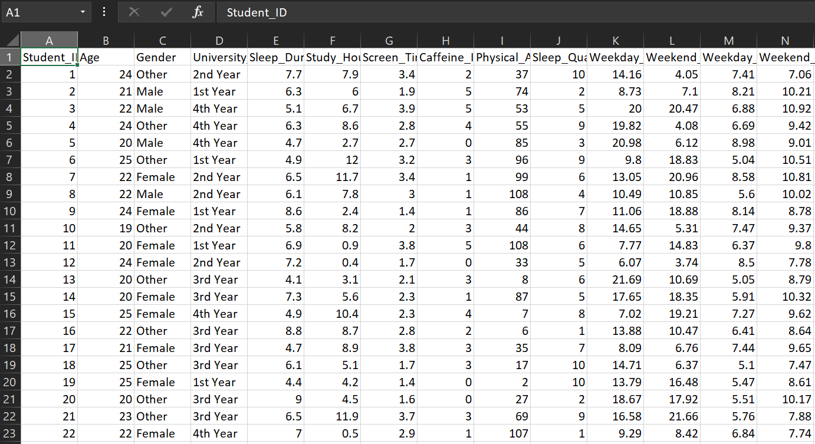

Fig 1.1 A screen snippet of the dataset.

References

1. American Thoracic Society, M.M.D. Ashesha, 2022

<https://www.thoracic.org/members/assemblies/assemblies/srn/questionaires/psqi.php>

1. Kaggle sleep pattern dataset

<https://www.kaggle.com/datasets/arsalanjamal002/student-sleep-patterns>